Re-générer les images une par une à partir de l'interface

graphique et du package de classes de tests.
Téléchargement des sources
Compilation des sources
Premier lancement du programme
Ouverture de fichiers
Rendu vers fichier

Première série de tests sans textures et sans lumières
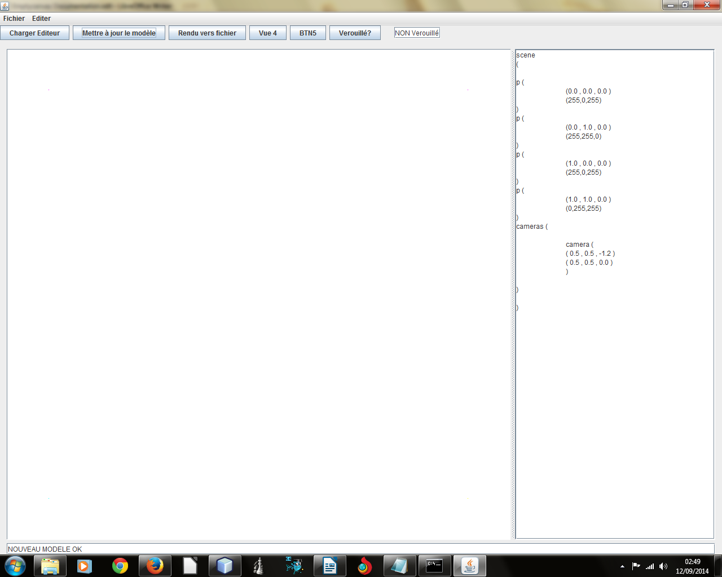
scene
(

p (
(0.0 , 0.0 , 0.0 )
(255,0,255)
)
p (
(0.0 , 1.0 , 0.0 )
(255,255,0)
)
p (
(1.0 , 0.0 , 0.0 )
(255,0,255)
)
p (
(1.0 , 1.0 , 0.0 )
(0,255,255)
)
cameras (

camera (
( 0.5 , 0.5 , -1.2 )
( 0.5 , 0.5 , 0.0 )
)

)

)

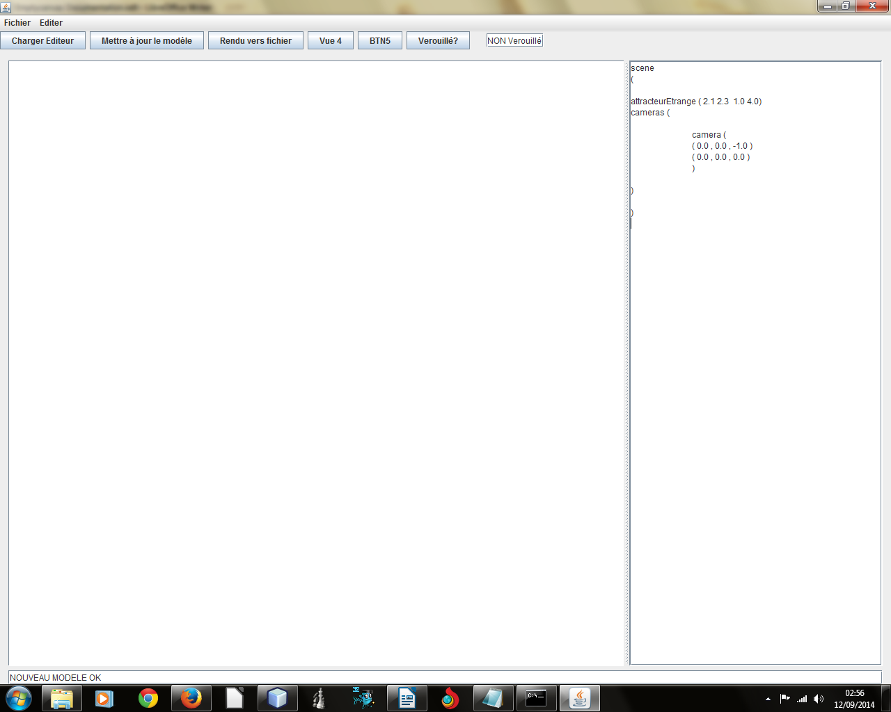
scene
(

attracteurEtrange ( 2.1 2.3 1.0 4.0)
cameras (

camera (
( 0.0 , 0.0 , -1.0 )
( 0.0 , 0.0 , 0.0 )
)

)

)
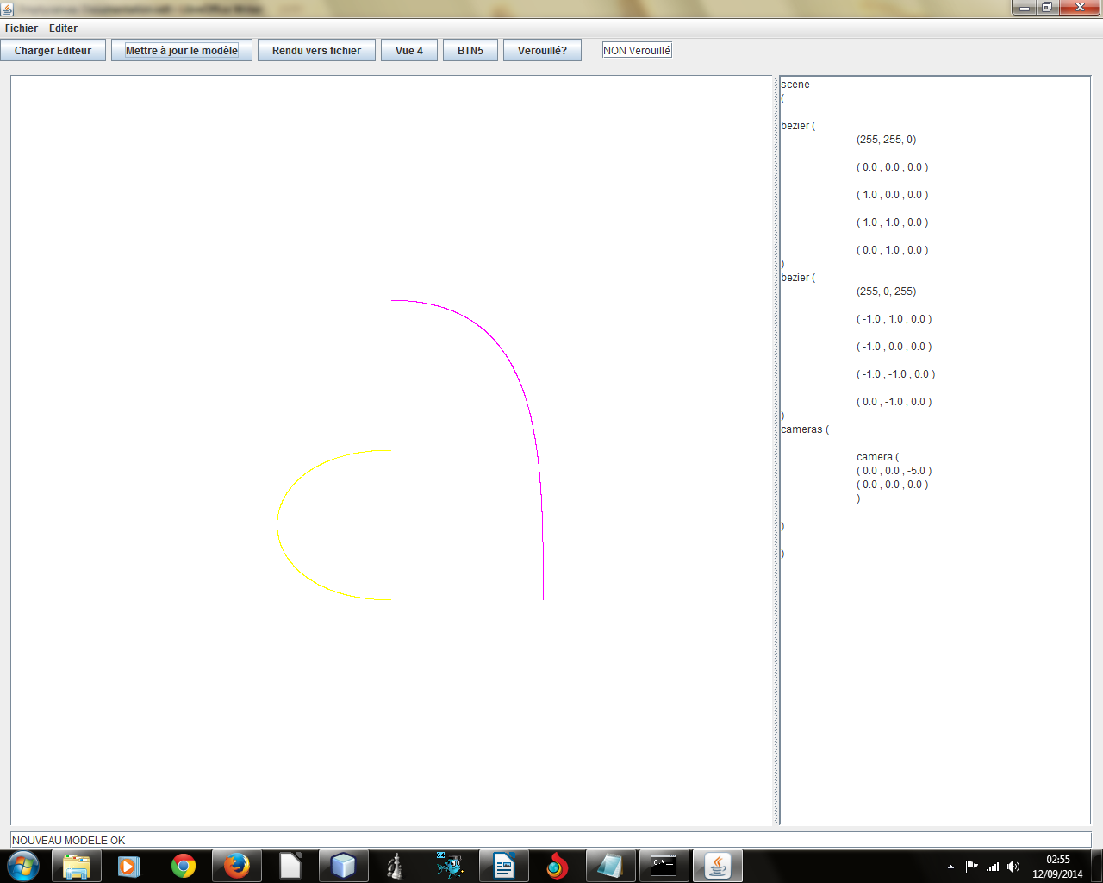
scene
(

bezier (
(255, 255, 0)

( 0.0 , 0.0 , 0.0 )

( 1.0 , 0.0 , 0.0 )

( 1.0 , 1.0 , 0.0 )

( 0.0 , 1.0 , 0.0 )
)
bezier (
(255, 0, 255)

( -1.0 , 1.0 , 0.0 )

( -1.0 , 0.0 , 0.0 )

( -1.0 , -1.0 , 0.0 )

( 0.0 , -1.0 , 0.0 )
)
cameras (

camera (
( 0.0 , 0.0 , -5.0 )
( 0.0 , 0.0 , 0.0 )
)

)

)
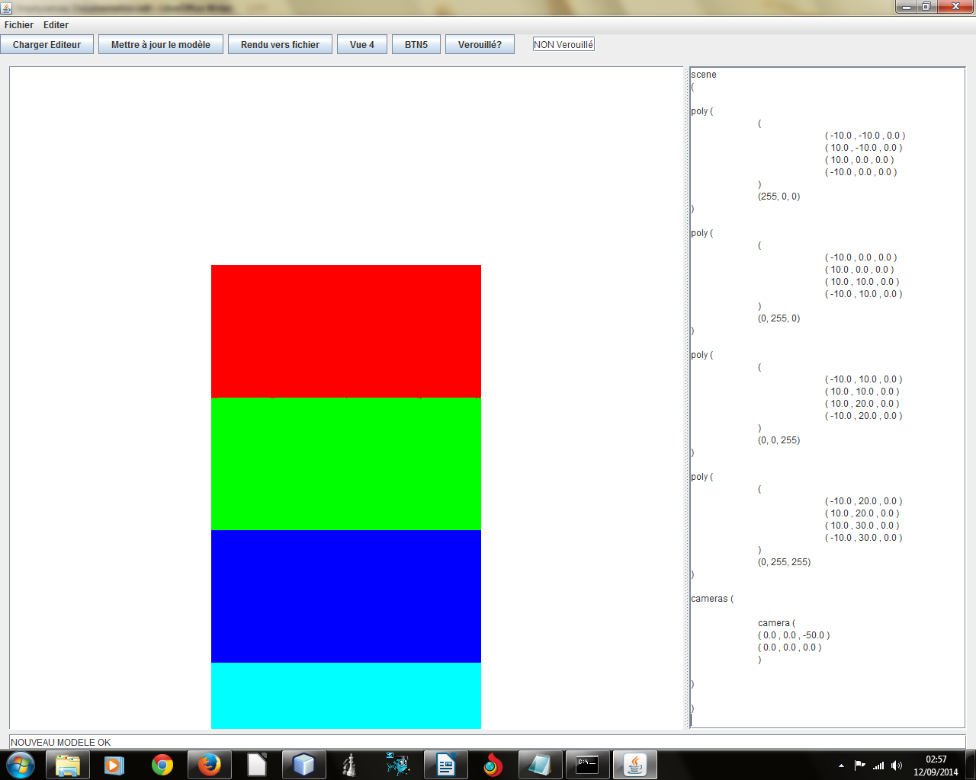
scene
(

poly (
(
( -10.0 , -10.0 , 0.0 )
( 10.0 , -10.0 , 0.0 )
( 10.0 , 0.0 , 0.0 )
( -10.0 , 0.0 , 0.0 )
)
(255, 0, 0)
)

poly (
(
( -10.0 , 0.0 , 0.0 )
( 10.0 , 0.0 , 0.0 )
( 10.0 , 10.0 , 0.0 )
( -10.0 , 10.0 , 0.0 )
)
(0, 255, 0)
)

poly (
(
( -10.0 , 10.0 , 0.0 )
( 10.0 , 10.0 , 0.0 )
( 10.0 , 20.0 , 0.0 )
( -10.0 , 20.0 , 0.0 )
)
(0, 0, 255)
)

poly (
(
( -10.0 , 20.0 , 0.0 )
( 10.0 , 20.0 , 0.0 )
( 10.0 , 30.0 , 0.0 )
( -10.0 , 30.0 , 0.0 )
)
(0, 255, 255)
)

cameras (

camera (
( 0.0 , 0.0 , -50.0 )
( 0.0 , 0.0 , 0.0 )
)

)

)
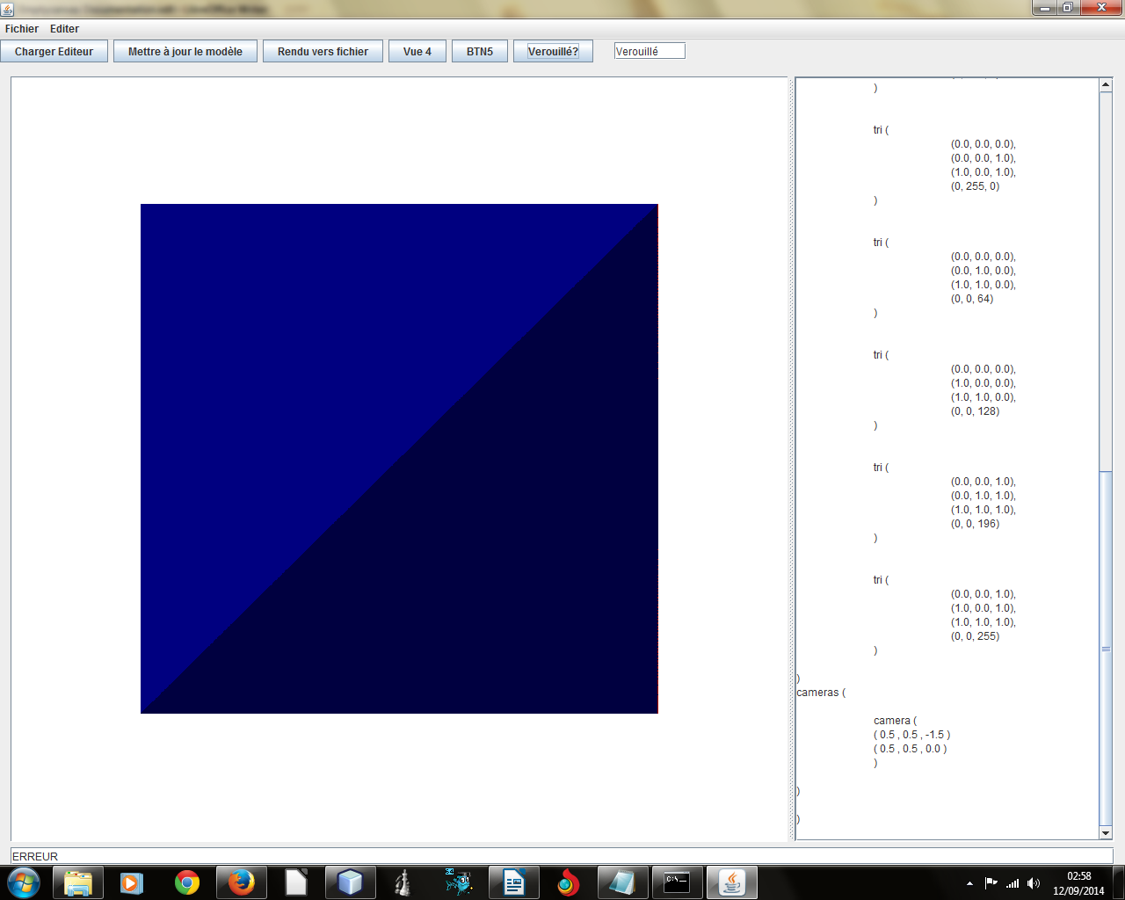
scene
(

tris(

tri (
(1.0, 0.0, 0.0),
(1.0, 1.0, 0.0),
(1.0, 1.0, 1.0),
(64, 0, 0)
)

tri (
(1.0, 0.0, 0.0),
(1.0, 0.0, 1.0),
(1.0, 1.0, 1.0),
(128, 0, 0)
)

tri (
(0.0, 0.0, 0.0),
(0.0, 1.0, 0.0),
(0.0, 1.0, 1.0),
(176, 0, 0)
)

tri (
(0.0, 0.0, 0.0),
(0.0, 0.0, 1.0),
(0.0, 1.0, 1.0),
(255, 0, 0)
)

tri (
(0.0, 1.0, 0.0),
(1.0, 1.0, 0.0),
(1.0, 1.0, 1.0),
(0, 64, 0)
)

tri (
(0.0, 1.0, 0.0),
(0.0, 1.0, 1.0),
(1.0, 1.0, 1.0),
(0, 128, 0)
)

tri (
(0.0, 0.0, 0.0),
(1.0, 0.0, 0.0),
(1.0, 0.0, 1.0),
(0, 196, 0)
)

tri (
(0.0, 0.0, 0.0),
(0.0, 0.0, 1.0),
(1.0, 0.0, 1.0),
(0, 255, 0)
)

tri (
(0.0, 0.0, 0.0),
(0.0, 1.0, 0.0),
(1.0, 1.0, 0.0),
(0, 0, 64)
)

tri (
(0.0, 0.0, 0.0),
(1.0, 0.0, 0.0),
(1.0, 1.0, 0.0),
(0, 0, 128)
)

tri (
(0.0, 0.0, 1.0),
(0.0, 1.0, 1.0),
(1.0, 1.0, 1.0),
(0, 0, 196)
)

tri (
(0.0, 0.0, 1.0),
(1.0, 0.0, 1.0),
(1.0, 1.0, 1.0),
(0, 0, 255)
)

)
cameras (

camera (
( 0.5 , 0.5 , -1.5 )
( 0.5 , 0.5 , 0.0 )
)

)

)
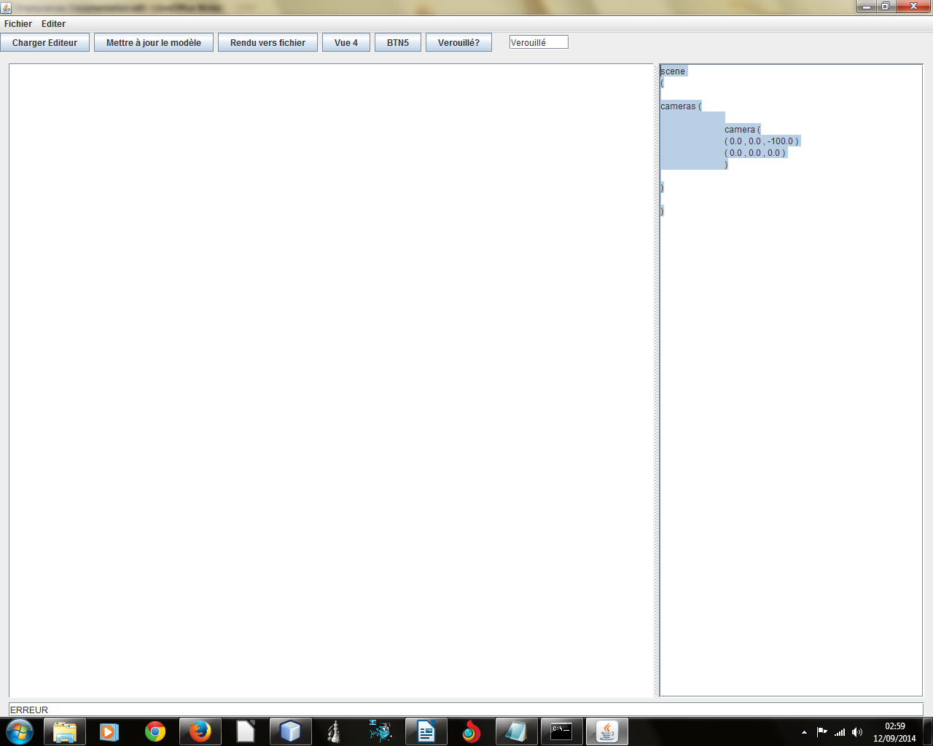
?? plans (noirs) .MOOD

scene
(

cameras (

camera (
( 0.0 , 0.0 , -100.0 )
( 0.0 , 0.0 , 0.0 )
)

)

)
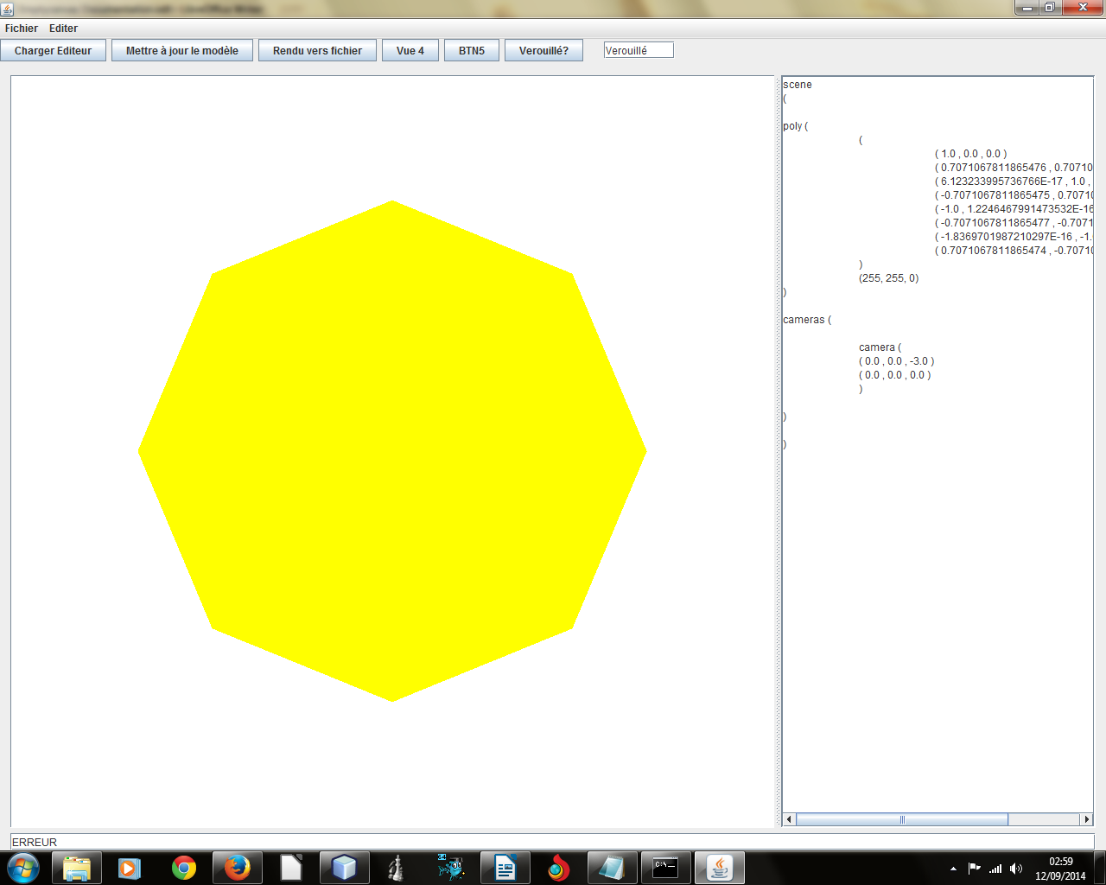
scene
(

poly (
(
( 1.0 , 0.0 , 0.0 )
( 0.7071067811865476 , 0.7071067811865475 , 0.0 )
( 6.123233995736766E-17 , 1.0 , 0.0 )
( -0.7071067811865475 , 0.7071067811865476 , 0.0 )
( -1.0 , 1.2246467991473532E-16 , 0.0 )
( -0.7071067811865477 , -0.7071067811865475 , 0.0 )
( -1.8369701987210297E-16 , -1.0 , 0.0 )
( 0.7071067811865474 , -0.7071067811865477 , 0.0 )
)
(255, 255, 0)
)

cameras (

camera (
( 0.0 , 0.0 , -3.0 )
( 0.0 , 0.0 , 0.0 )
)

)

)

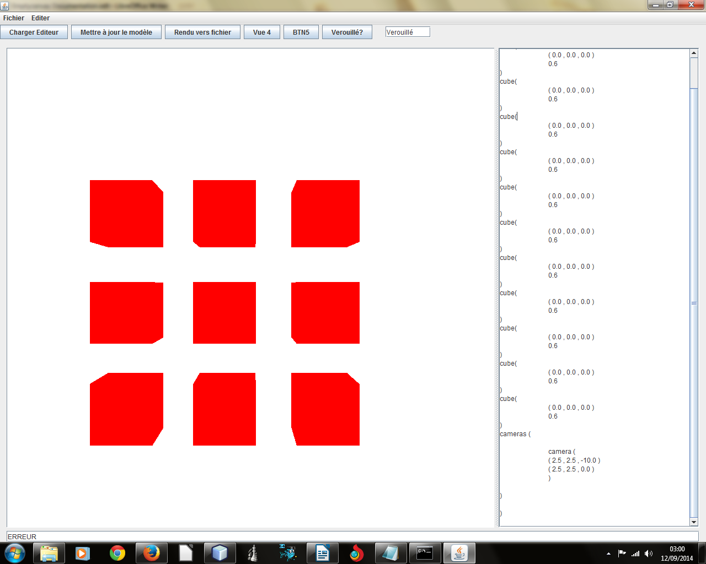

scene
(

cube(
( 0.0 , 0.0 , 0.0 )
0.6
)
cube(
( 0.0 , 0.0 , 0.0 )
0.6
)
cube(
( 0.0 , 0.0 , 0.0 )
0.6
)
cube(
( 0.0 , 0.0 , 0.0 )
0.6
)
cube(
( 0.0 , 0.0 , 0.0 )
0.6
)
cube(
( 0.0 , 0.0 , 0.0 )
0.6
)
cube(
( 0.0 , 0.0 , 0.0 )
0.6
)
cube(
( 0.0 , 0.0 , 0.0 )
0.6
)
cube(
( 0.0 , 0.0 , 0.0 )
0.6
)
cube(
( 0.0 , 0.0 , 0.0 )
0.6
)
cube(
( 0.0 , 0.0 , 0.0 )
0.6
)
cameras (

camera (
( 2.5 , 2.5 , -10.0 )
( 2.5 , 2.5 , 0.0 )
)

)

)

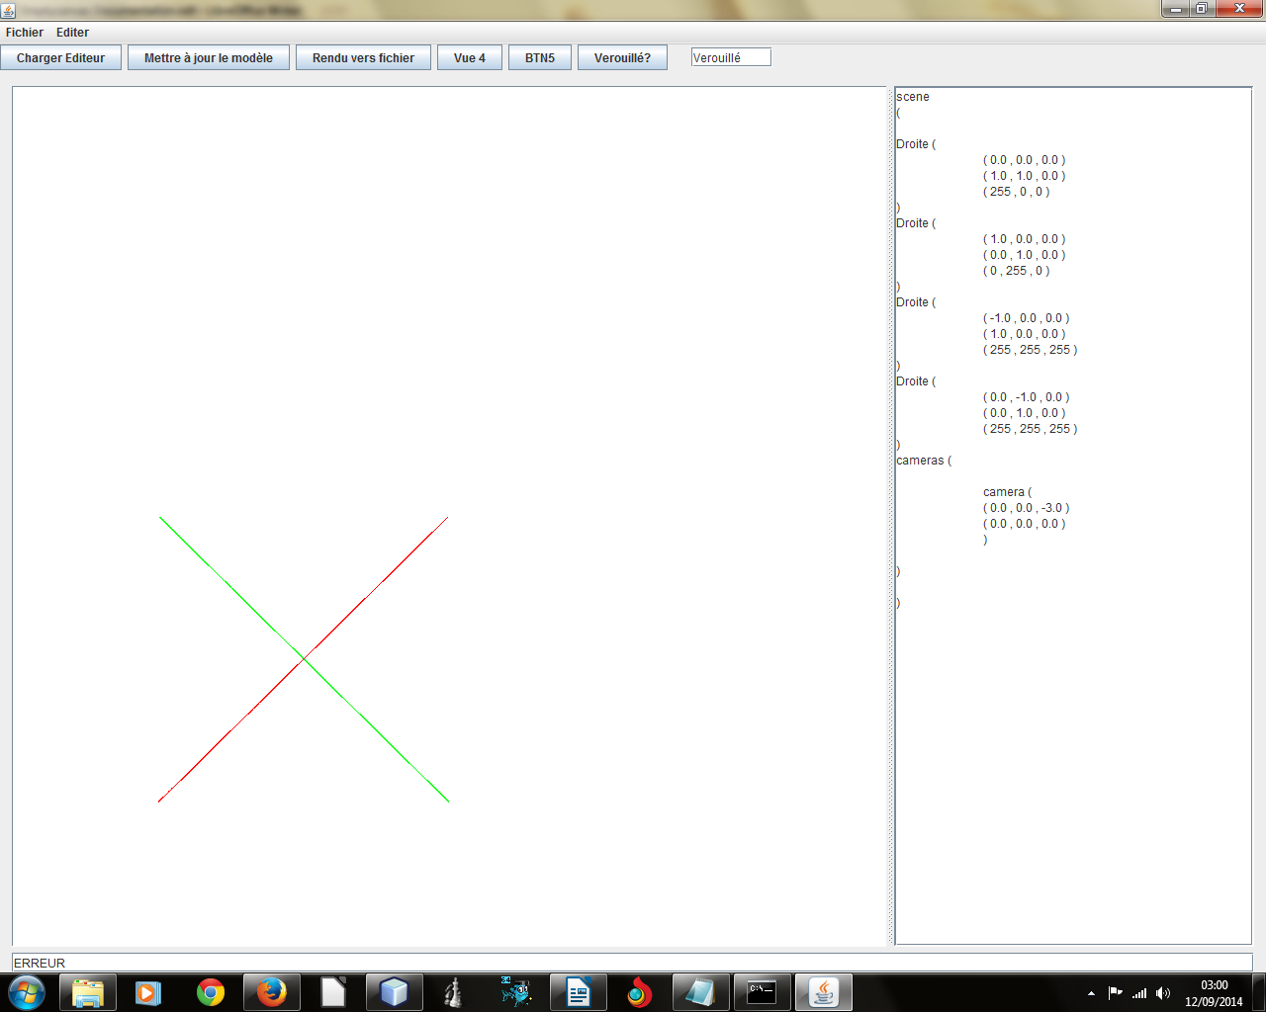
scene
(

Droite (
( 0.0 , 0.0 , 0.0 )
( 1.0 , 1.0 , 0.0 )
( 255 , 0 , 0 )
)
Droite (
( 1.0 , 0.0 , 0.0 )
( 0.0 , 1.0 , 0.0 )
( 0 , 255 , 0 )
)
Droite (
( -1.0 , 0.0 , 0.0 )
( 1.0 , 0.0 , 0.0 )
( 255 , 255 , 255 )
)
Droite (
( 0.0 , -1.0 , 0.0 )
( 0.0 , 1.0 , 0.0 )
( 255 , 255 , 255 )
)
cameras (

camera (
( 0.0 , 0.0 , -3.0 )
( 0.0 , 0.0 , 0.0 )
)

)

)
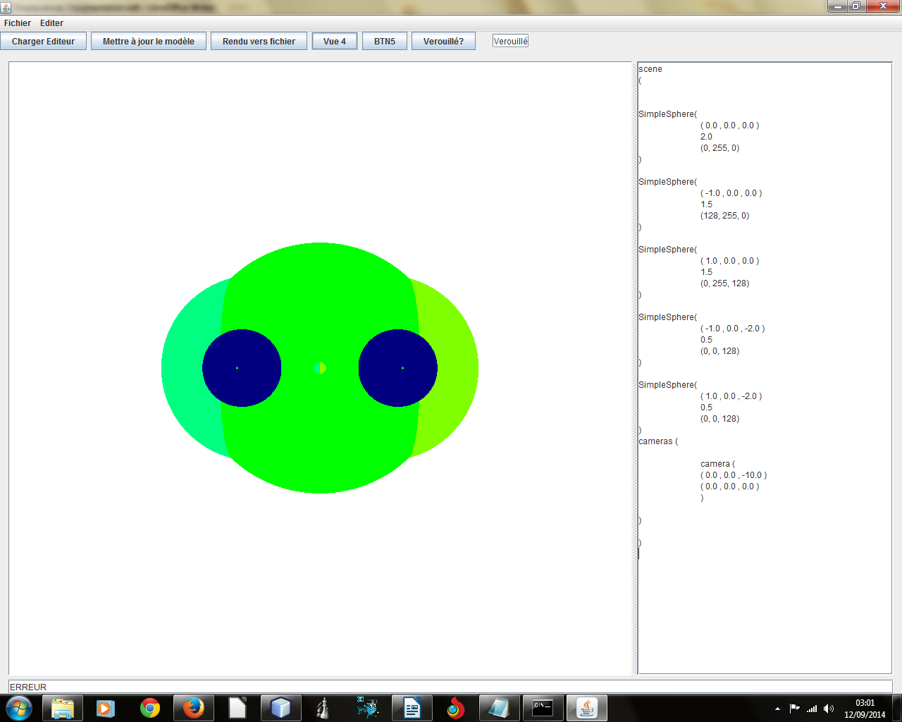
scene
(

SimpleSphere(
( 0.0 , 0.0 , 0.0 )
2.0
(0, 255, 0)
)

SimpleSphere(
( -1.0 , 0.0 , 0.0 )
1.5
(128, 255, 0)
)

SimpleSphere(
( 1.0 , 0.0 , 0.0 )
1.5
(0, 255, 128)
)

SimpleSphere(
( -1.0 , 0.0 , -2.0 )
0.5
(0, 0, 128)
)

SimpleSphere(
( 1.0 , 0.0 , -2.0 )
0.5
(0, 0, 128)
)
cameras (

camera (
( 0.0 , 0.0 , -10.0 )
( 0.0 , 0.0 , 0.0 )
)

)

)
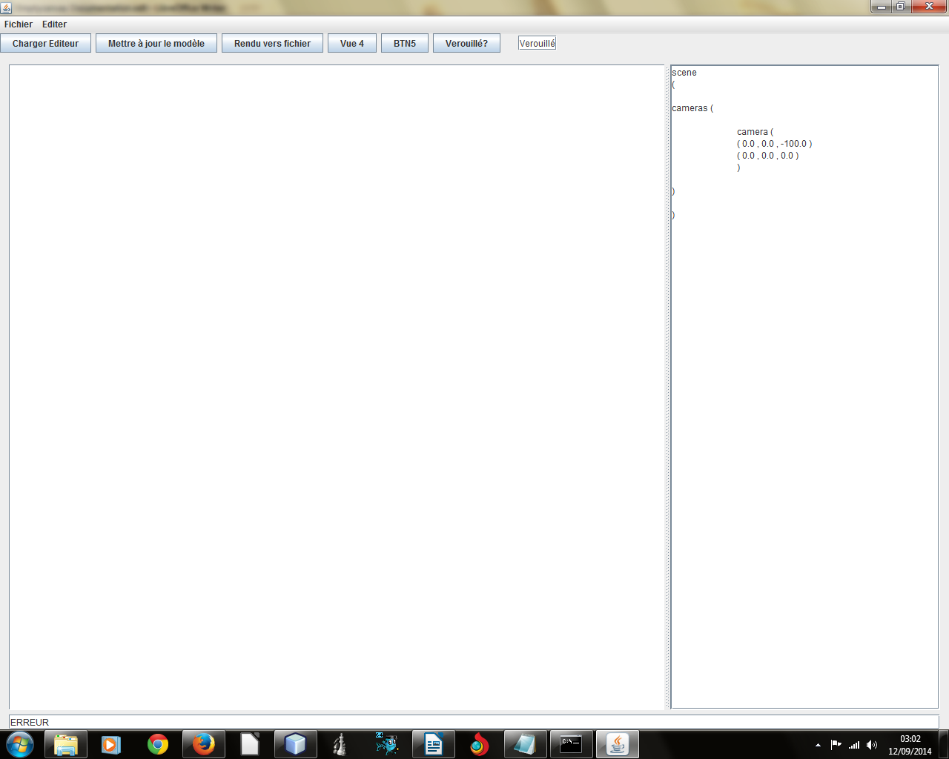

?? SHERE ROUGE

scene
(

cameras (

camera (
( 0.0 , 0.0 , -100.0 )
( 0.0 , 0.0 , 0.0 )
)

)

)
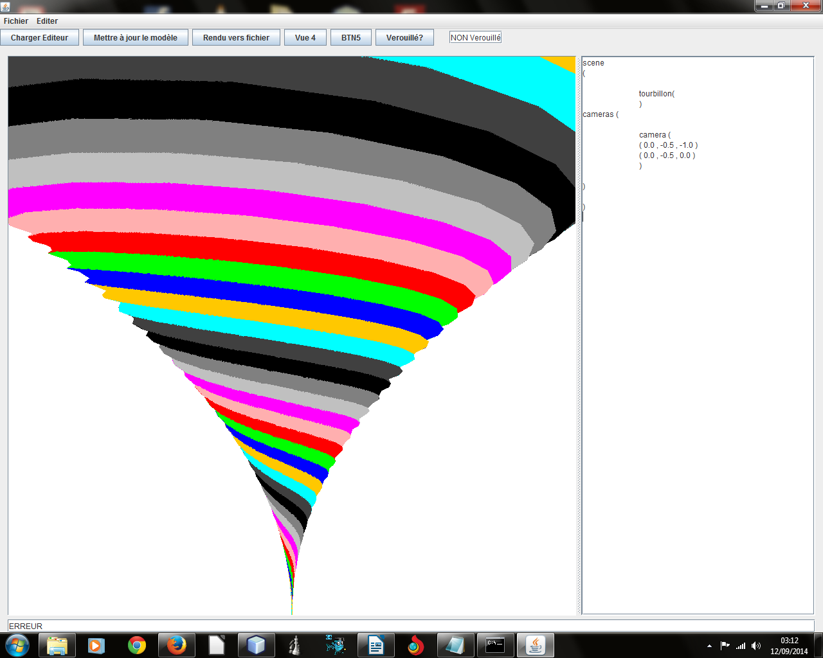
scene
(

tourbillon(
)
cameras (

camera (
( 0.0 , -0.5 , -1.0 )
( 0.0 , -0.5 , 0.0 )
)

)

)
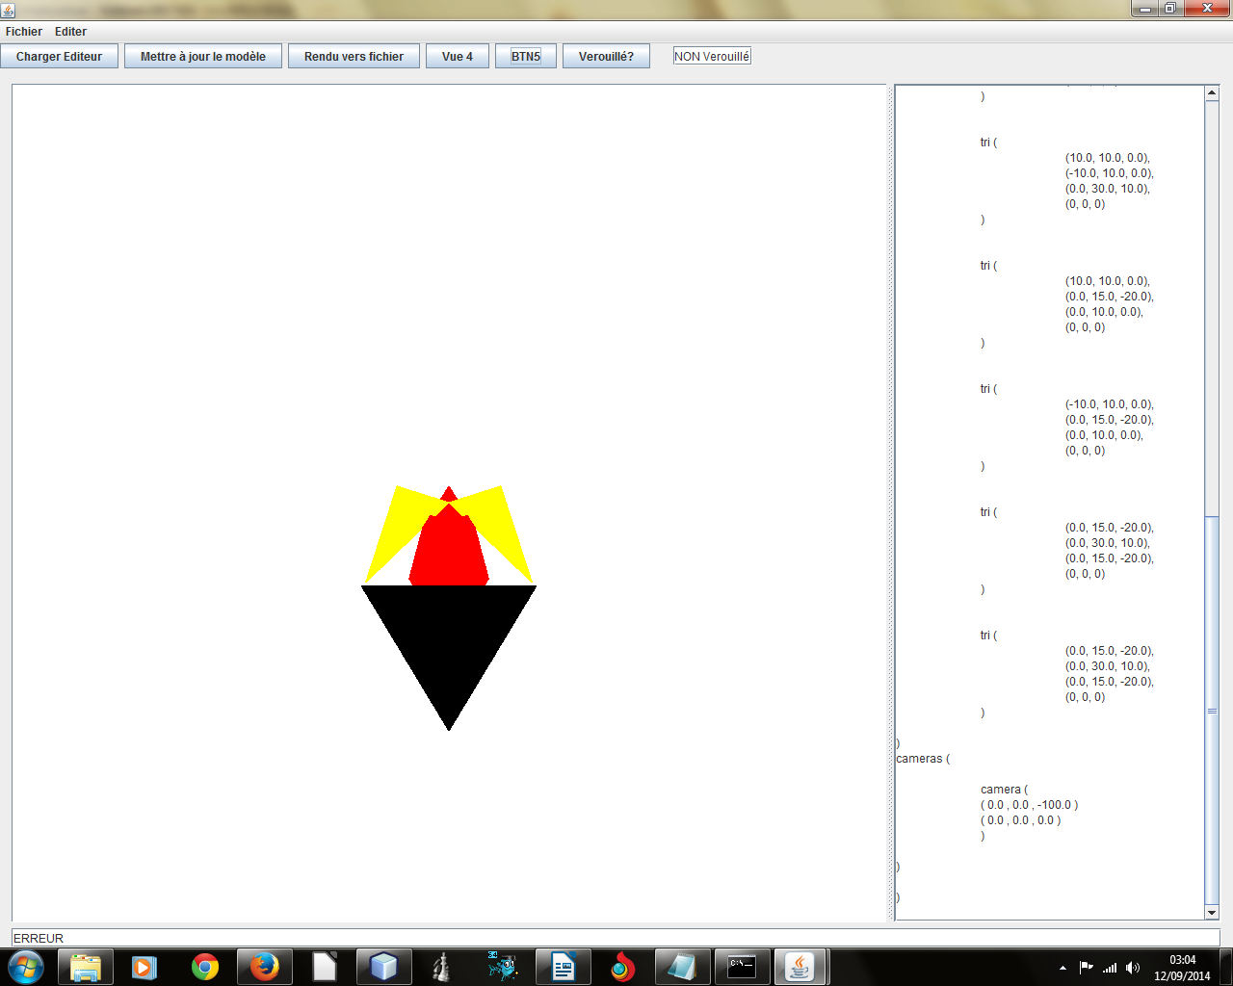
scene
(

tris(

tri (
(10.0, 10.0, 5.0),
(6.0, -2.0, 1.0),
(0.0, 0.0, 0.0),
(255, 255, 0)
)

tri (
(-10.0, 10.0, 5.0),
(-6.0, -2.0, 1.0),
(0.0, 0.0, 0.0),
(255, 255, 0)
)

tri (
(3.0, 3.0, 0.0),
(-3.0, 3.0, 0.0),
(0.0, -2.0, 3.0),
(255, 0, 0)
)

tri (
(3.0, 3.0, 0.0),
(0.0, 3.0, 0.0),
(5.0, 10.0, 10.0),
(255, 0, 0)
)

tri (
(-3.0, 3.0, 0.0),
(0.0, 3.0, 0.0),
(-5.0, 10.0, 10.0),
(255, 0, 0)
)

tri (
(0.0, 3.0, 0.0),
(5.0, 10.0, 10.0),
(0.0, 20.0, 20.0),
(255, 0, 0)
)

tri (
(0.0, 3.0, 0.0),
(-5.0, 10.0, 10.0),
(0.0, 20.0, 20.0),
(255, 0, 0)
)

tri (
(10.0, 10.0, 0.0),
(-10.0, 10.0, 0.0),
(0.0, 30.0, 10.0),
(0, 0, 0)
)

tri (
(10.0, 10.0, 0.0),
(0.0, 15.0, -20.0),
(0.0, 10.0, 0.0),
(0, 0, 0)
)

tri (
(-10.0, 10.0, 0.0),
(0.0, 15.0, -20.0),
(0.0, 10.0, 0.0),
(0, 0, 0)
)

tri (
(0.0, 15.0, -20.0),
(0.0, 30.0, 10.0),
(0.0, 15.0, -20.0),
(0, 0, 0)
)

tri (
(0.0, 15.0, -20.0),
(0.0, 30.0, 10.0),
(0.0, 15.0, -20.0),
(0, 0, 0)
)

)
cameras (

camera (
( 0.0 , 0.0 , -100.0 )
( 0.0 , 0.0 , 0.0 )
)

)

)

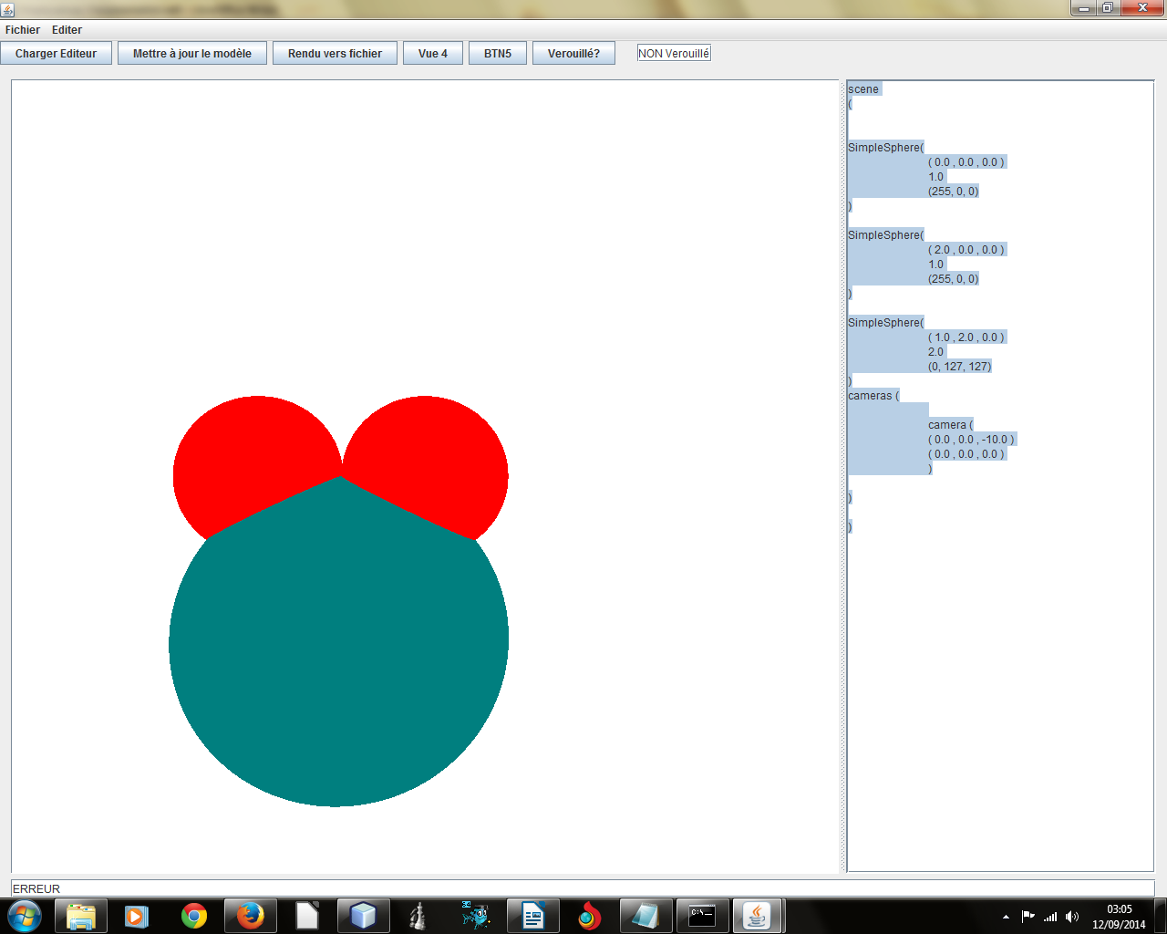
scene
(

SimpleSphere(
( 0.0 , 0.0 , 0.0 )
1.0
(255, 0, 0)
)

SimpleSphere(
( 2.0 , 0.0 , 0.0 )
1.0
(255, 0, 0)
)

SimpleSphere(
( 1.0 , 2.0 , 0.0 )
2.0
(0, 127, 127)
)
cameras (

camera (
( 0.0 , 0.0 , -10.0 )
( 0.0 , 0.0 , 0.0 )
)

)

)
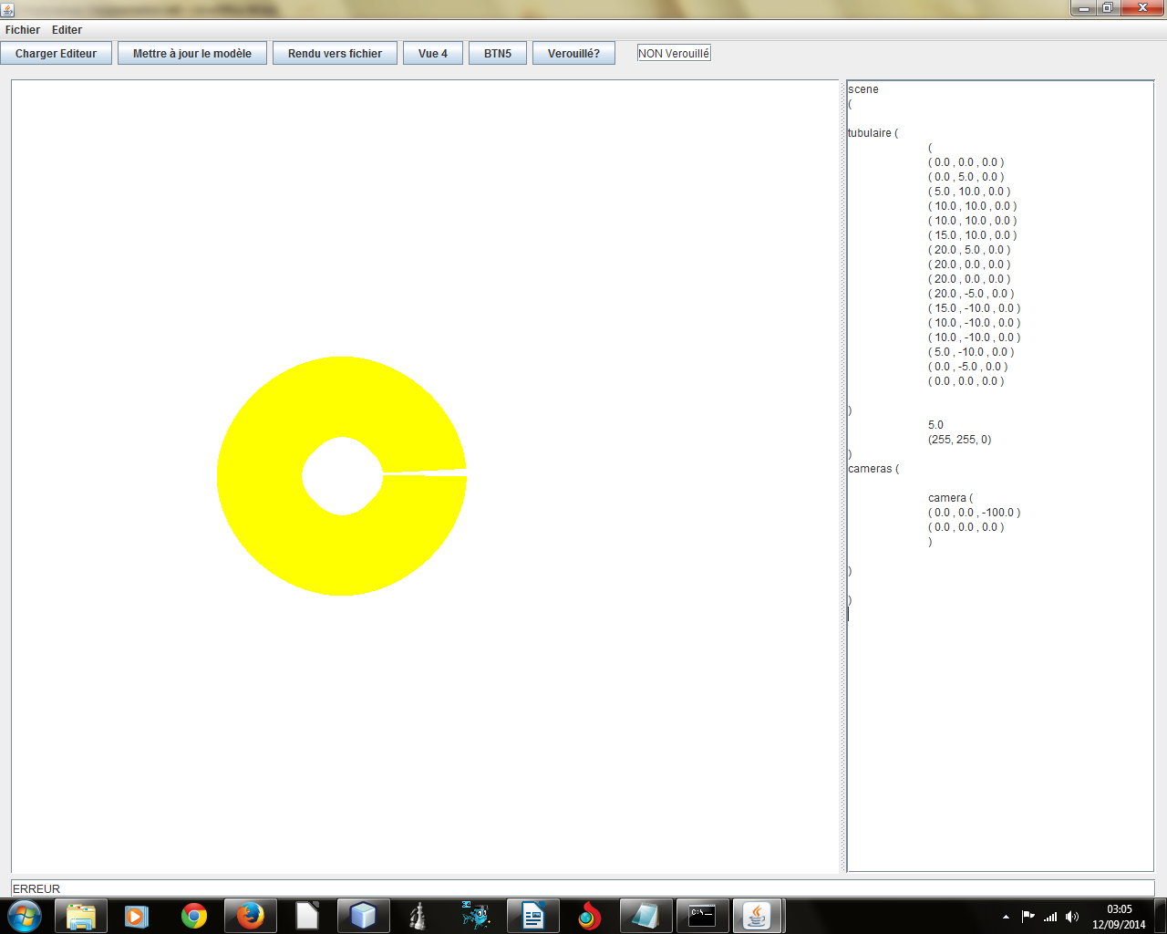
scene
(

tubulaire (
(
( 0.0 , 0.0 , 0.0 )
( 0.0 , 5.0 , 0.0 )
( 5.0 , 10.0 , 0.0 )
( 10.0 , 10.0 , 0.0 )
( 10.0 , 10.0 , 0.0 )
( 15.0 , 10.0 , 0.0 )
( 20.0 , 5.0 , 0.0 )
( 20.0 , 0.0 , 0.0 )
( 20.0 , 0.0 , 0.0 )
( 20.0 , -5.0 , 0.0 )
( 15.0 , -10.0 , 0.0 )
( 10.0 , -10.0 , 0.0 )
( 10.0 , -10.0 , 0.0 )
( 5.0 , -10.0 , 0.0 )
( 0.0 , -5.0 , 0.0 )
( 0.0 , 0.0 , 0.0 )

)
5.0
(255, 255, 0)
)
cameras (

camera (
( 0.0 , 0.0 , -100.0 )
( 0.0 , 0.0 , 0.0 )
)

)

)
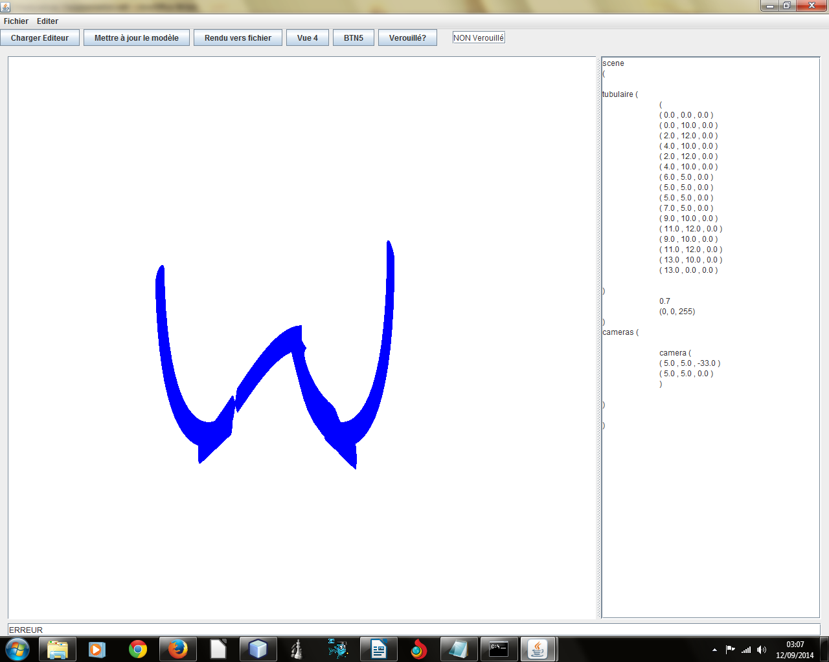
scene
(

tubulaire (
(
( 0.0 , 0.0 , 0.0 )
( 0.0 , 10.0 , 0.0 )
( 2.0 , 12.0 , 0.0 )
( 4.0 , 10.0 , 0.0 )
( 2.0 , 12.0 , 0.0 )
( 4.0 , 10.0 , 0.0 )
( 6.0 , 5.0 , 0.0 )
( 5.0 , 5.0 , 0.0 )
( 5.0 , 5.0 , 0.0 )
( 7.0 , 5.0 , 0.0 )
( 9.0 , 10.0 , 0.0 )
( 11.0 , 12.0 , 0.0 )
( 9.0 , 10.0 , 0.0 )
( 11.0 , 12.0 , 0.0 )
( 13.0 , 10.0 , 0.0 )
( 13.0 , 0.0 , 0.0 )

)
0.7
(0, 0, 255)
)
cameras (

camera (
( 5.0 , 5.0 , -33.0 )
( 5.0 , 5.0 , 0.0 )
)

)

)

